**Task 5 : The syntax for all loops in shell scripting**

**For Loop :**

**Assignment 1 :**

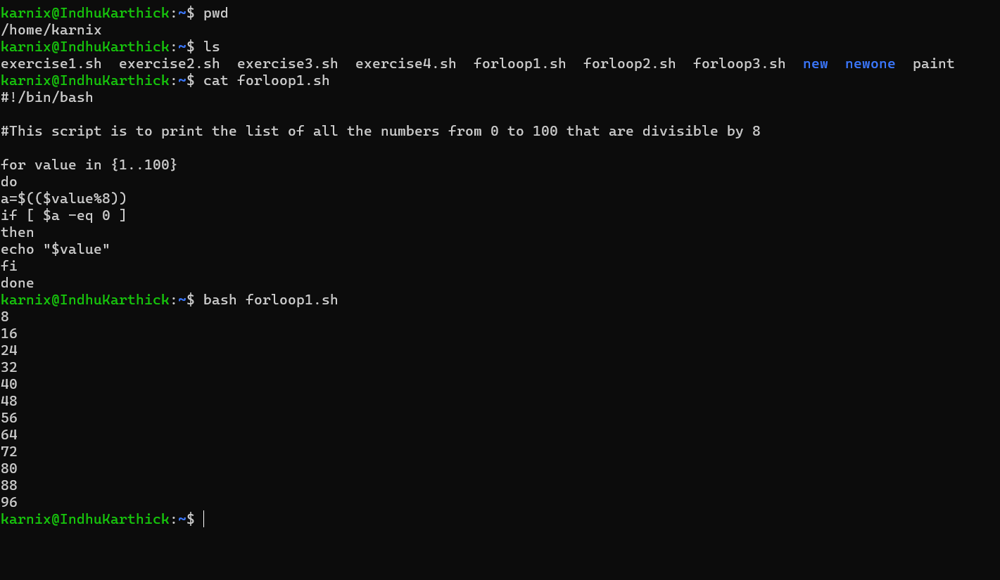

**Assignment 2 :**

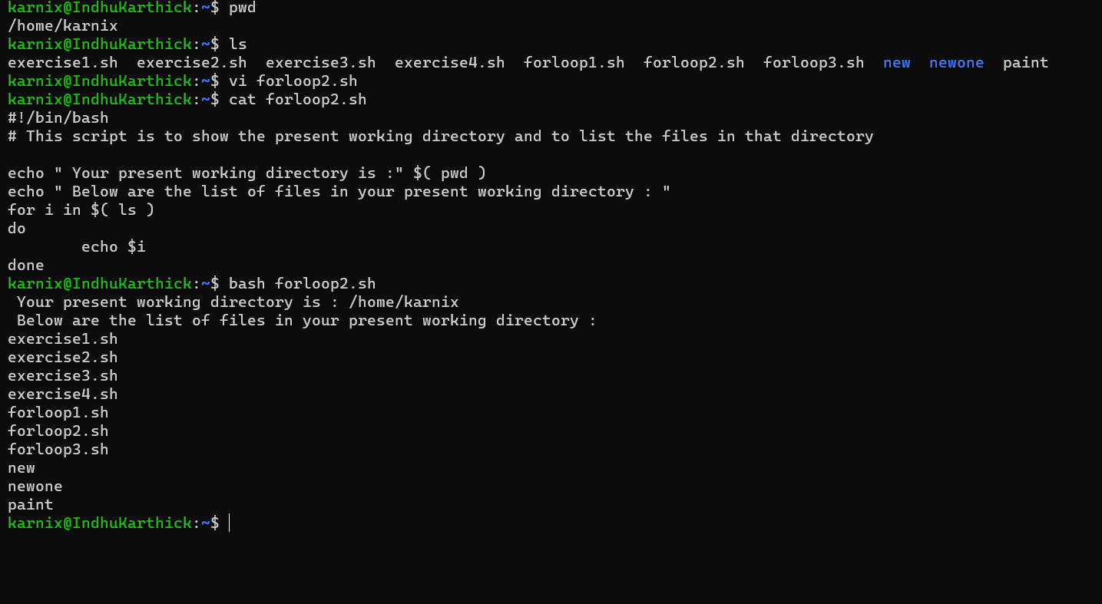

**Assignment 3 :**

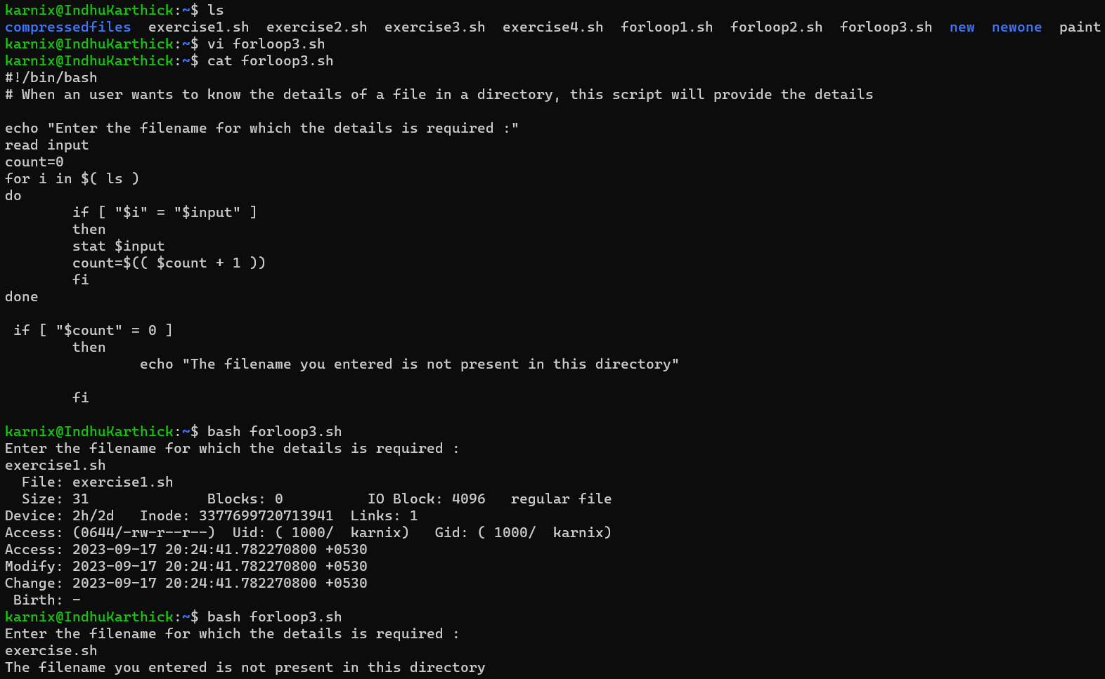

**While Loop :**

**Assignment 1 :**

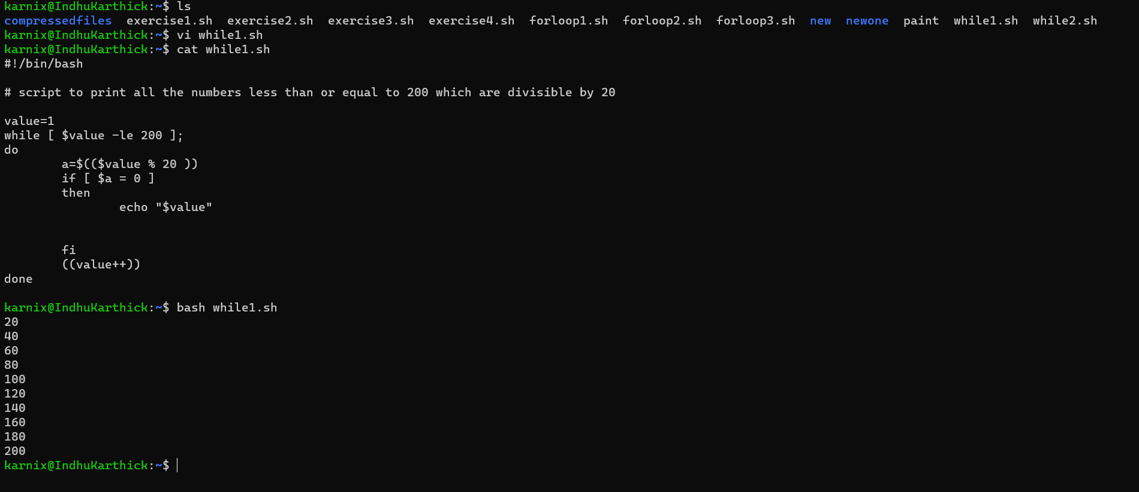

**Assignment 2 :**

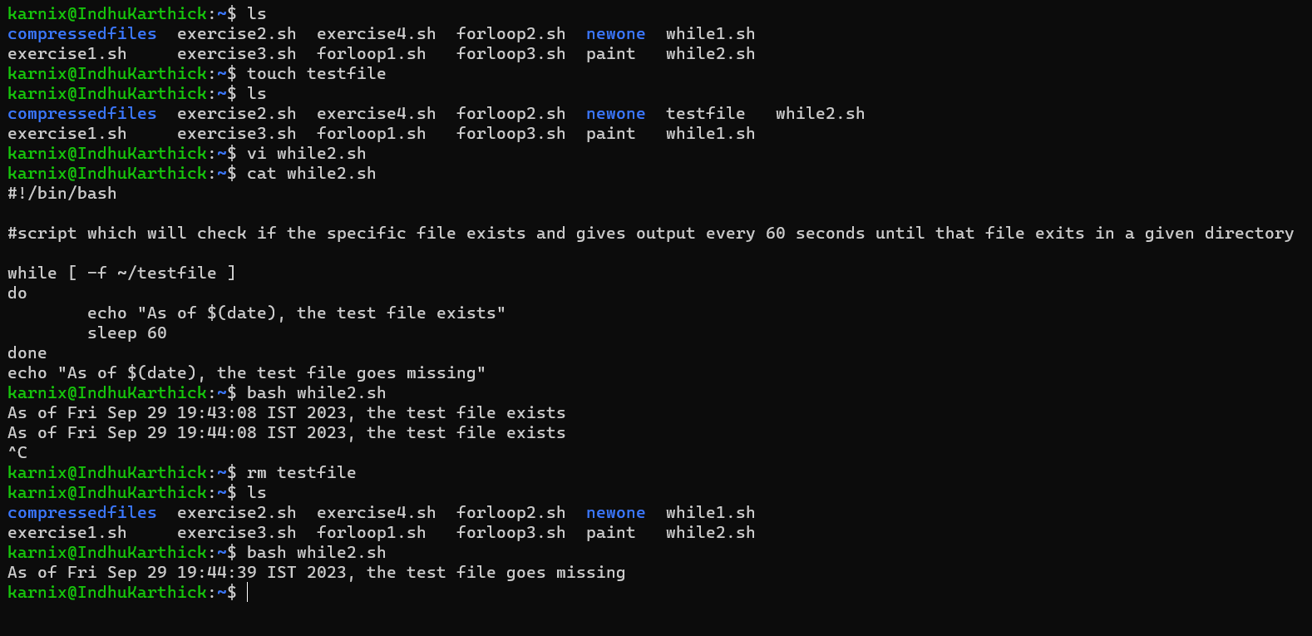

**Until Loop :**

**Assignment 1 :**

